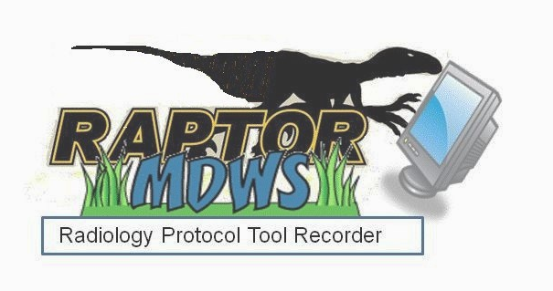

RAPTOR User Acceptance Test Plan (UATP)

Date: March 18, 2014

Draft Version:

Revision History & Sign-off Sheet

Change Record

Version | Date | Name | Revision Description

Reviewers

Name | Version Approved | Role | Date

Distribution

Name | Date

Document Properties

Item | Details
Document Title
Author
Creation Date
Last Updated

Table of Contents

1.0 Introduction 4
1.1 Project Overview 4
1.2 Scope 4
1.2.1 In Scope 4
1.2.2 Out of Scope 12
1.3 Objective 12
1.3.1 Primary Objective 12
1.3.2 Secondary Objective 12
2.0 UA Test Approach 12
2.1 Test Phases 13
3.0 UA Test Environment 13
3.1 UA Test Preparation 14
3.2 UA Test Data 14
4.0 Roles and Responsibilities 14
4.1 UAT Team 14
5.0 UAT Deliverables 18
5.1 UAT Activities 18
5.2 UAT Schedule 18
6.0 UA Test Cases 19
6.1 UA Test Cases 19
7.0 UAT Defects 19
7.1 UAT Defect Tracking 19
7.2 UAT Defect Prioritization 19
7.3 UAT Defect Lifecycle 20
8.0 Assumptions 20

1.0 Introduction
The purpose of this document is to outline the S.A.N. Business Consultants (SAN) User Acceptance Testing (UAT) process for the RAPTOR phase 2. This document will detail the UI test approach and what will be demonstrated for each increment. UAT is conducted to enable a user to validate that the software meets the agreed upon acceptance criteria.

SAN’s role in the UAT process is to oversee testing by assigning scripts to SMEs, providing general support, and serving as the primary UAT contact point throughout the test cycle. SAN will filter out any duplicate defects found and escalate high priority issues to the developers in a time sensitive manner.

Project Overview
SAN shall enhance the current PoC RAPTOR Prototype by adding new functionalities as defined in the following table to improve the usability of the imaging exam ordering process. Through these enhancements, the imaging exam ordering process between the radiologist and the ordering provider shall allow the radiologist to access sufficient patient data (e.g., allergies, medications, provider notes, imaging reports, ionizing radiation exposure history) before assigning specific protocol instructions to direct how each examination must be performed by the ordering provider. These enhancements shall be collectively known as the Production RAPTOR Prototype. SAN shall provide pilot User Acceptance Test (UAT) support services to implement the Production RAPTOR Prototype. SAN shall procure, configure, prepare, deliver, and install the hardware that goes into the VA Region 1 Sacramento Data Center. SAN shall also install the Production RAPTOR Prototype applications at four additional VA Pilot production environments as identified in Sections 4.2 and 5.2.4 of this PWS. The VA Region 1 Sacramento Data Center, plus the four aforementioned VA Pilot production environments, that comprise the five VA pilot sites required by this PWS.

1.2 Scope

1.2.1 In Scope
The following table (Table 1) shows the functional enhancements in scope for the March 23, 2014 Increment.

Table 1 - Scope
Item No. | Functional Enhancements for Production RAPTOR Prototype | Test Readiness | Out of Scope for this Release
1.1 | Contra-indications shall be clickable to go into details. | 3/23 –demonstration of partial implementation. Need details from SME. | Developers need details from Medical SME.
1.2 | Sort on work list by column. | 3/23 –demonstration of partial implementation.
1.3 | Radiation Dose shall be enhanced to calculate a moving average on each radiation dose episode to create a dose data set. |  | Developers need details from Medical SME.
1.4 | RAPTOR shall be enhanced to add additional automatic pre-populated fields based on protocols to improve efficiency (e.g., have protocol contrast volumes pre-populate tech notes section; in that way tech does not need to enter data unless actual volume differed from planned). | Use Templates Concept based on protocol library content.  3/23 –demonstration of partial implementation.
1.5 | Improve the Refer Specialist concept. RAPTOR shall identify specialty role in addition to individuals. Use cases: For large VISN or VHA National Teleradiology Program NTP, the user does not know who is the specialist but wants to collaborate. The specialty role will assist in collaboration. |  | Collaboration Concept keyword driven.  Developers need details from Medical SME.
1.6 | Improve the reporting functionality to include measurements of department efficiency. |  | Developers need details from Medical SME.
1.7 | Improve the reporting functionality to include the tracking of user actions to determine effectiveness. |  | Developers need details from Medical SME.
1.8 | Improve the summary report concept such that details of medical decisions and actions for the examination protocol and execution are easily found within medical record. |  | Developers need details from Medical SME.
1.9 | Auto-populate fields. (e.g., protocol contrast volumes default into tech notes page, then only need to do further entry if amount was different). | For prototype: in the Ready for Examination mode, the pre-medication actions are auto-populated into the tech notes.  3/23 –demonstration of partial implementation TBD.
1.10 | Include facility/administrator configurability. |  | Planned for future increment
1.11 | Administrator shall be able to add an order to work list manually (e.g. ultrasound guided procedure needing protocol assignment). |  | Planned for future increment
1.12 | Enable/Improve search functionality on all information tabs. |  | Search in browser works in prototype. Improved search planned for future increment
1.13 | Notes and lab tabs should be brought up to original presentation concept (e.g. Notes default most recent progress or primary care note, then most recent d/c summary, then most recent h&p, then reverse chronological order. |  | Planned for future increment
1.14 | Improve medication tab to include reconciliation with outside medication list. |  | Concept ok in prototype. Reconciliation is through administration function.
1.15 | Improve the allergies tab headings to reflect clinical data. | With seeded data, allergies in prototype. | With seeded data, allergies in prototype.
1.16 | Improve the Suspend ticket concept. In particular, suspension notifications and impact on other functionality shall be defined, designed, developed, tested and deployed. | Discussed improved navigation when incomplete page. Provide message, to reserve work in progress.  3/23 –demonstration of partial implementation.
1.17 | Add allergies thumbnail alert if risk is found. |  | Alert Concept in prototype covered by contraindications. Gather at risk agents.  Developers need details from Medical SME.
1.18 | If RAPTOR discovers more than five pending imaging orders on a patient, the user is given the opportunity to click to reveal/display complete listing of pending imaging exams. |  | Reveal/Display concept not in prototype. TBD in mockups.
1.19 | Include protocol templates to improve workflow efficiency and dose reduction. Adding this functionality will improve user acceptance of RAPTOR. It will benefit quality locally by promoting sharing of templates between users and nationally by sharing between sites. | Use Templates Concept based on protocol library content.  3/23 –demonstration of partial implementation.
1.20 | Specify for Nuclear Medicine (NM) workflow. This functionality will improve user acceptance of RAPTOR. |  | Developers need details from Medical SME.
1.21 | Allergy Contraindications: RAPTOR shall compare the patient's Allergy list against a set of user configurable key words to identify patients with a past history of adverse reaction to imaging contrast agents.  Default Key Words = Iodine, Iodinated, Contrast, Gadolinium, intravascular |  | Developers need details from Medical SME.  Planned for future increment
1.22 | Allergy Contraindications: If RAPTOR identifies a match suggesting a patient with potential allergy contraindication, then RAPTOR shall flag with user configurable message that consent is required.  DEFAULT MESSAGE = "CONSENT FOR IV CONTRAST REQUIRED, POTENTIAL HISTORY OF IMAGING CONTRAST DYE ALLERGY"  This flag must be acknowledged by user. |  | Planned for future increment
1.23 | Allergy Contraindications: User can acknowledge and still elect to proceed without consent required radio button checked and has option to indicate a reason in the protocol notes free text area.  If flag for consent conditions are true, RAPTOR then also displays the following configurable default message text  "POTENTIAL HISTORY OF IMAGING CONTRAST DYE ALLERGY, CONSIDER PROPHYLACTIC PREMEDICATION PROTOCOL"  User does not have to acknowledge this message. |  | Planned for future increment
1.24 | RAPTOR shall have a failsafe against someone abandoning a workstation and someone else sitting down and performing orders under prior person’s identity.  Example includes having a signature code that is requested at time of 1st approval command of a session. Then, the signature request will not be requested at subsequent approvals within same session. |  | Planned for future increment
1.25 | RAPTOR desktop security shall assign an automatic time for the application to close if not used. |  | Planned for future increment
1.26 | Add the Scheduled State between Approved and Protocol Acknowledged states. Preferably interface with scheduling system, if feasible. | User can manually enter scheduled date and time into worklist.  3/23 –demonstration of partial implementation.
1.27 | Add a column of scheduled date/time to work list. | 3/23 –demonstration of partial implementation.
1.28 | Highlight the work list to ER, STAT & Inpatient orders using visual cues. | 3/23 –demonstration of partial implementation.
1.29 | Enhance the work list scoring to include add-ins. |  | Planned for future increment
1.30 | Sort on work list by modality. This could be used to have a daily view into a modality type. | 3/23 –demonstration of partial implementation.
1.31 | Administrative function for facility personnel to manage user access and to provide audit trail. Include ability to add, modify, or delete protocols. |  | Admin Planned for future increment
1.32 | Ability to protocol other modalities such as ultrasound or fluoro studies. | 3/23 –demonstration of partial implementation.
1.33 | Display allergies, medication (metformin) and creatinine/ Glomerular Filtration Rate (GFR) in one area for ease of viewing. | 3/23 –demonstration of partial implementation.
1.34 | Include API that allows link to CPRS (in case further review of a patient’s record is required) and PACS (to review prior images). Ideally, these links will not require additional sign on. |  | Viewer being worked. Planned for future increment
1.35 | The worklist can be manually updated with scheduling date. Once a patient is scheduled, the application can retain this information. | 3/23 –demonstration of partial implementation.
1.36 | Automatic time out when the application is not in use (refer to item 25). |  | Planned for future increment
1.37 | Display any additional pending radiology exams to facilitate scheduling coordination; I would not limit the number of pending exams (see item 18). |  | Planned for future increment
2.0 | Enhancements Relating to Production RAPTOR Prototype Workflow
2.1 | Each facility may vary as to when a study is protocoled, some may protocol before scheduling, and others may do in reverse order. RAPTOR shall pull unscheduled orders as well as scheduled ones. Include scheduled date/time (See Item 27, above). For unscheduled orders, display “date desired”. | 3/23 –demonstration of partial implementation.
2.2 | Sort on work list | 3/23 –demonstration of partial sorting implementation.
2.3 | Display recent exams of same modalities, avoid duplicate scanning within a short period of time, reduce unnecessary radiation exposure and waste of resources. |  | Planned for future increment
2.4 | Separate out studies by location (Emergency Department (ED), inpatients, outpatients) as well as urgency (Stat) (See Item 1.28, above). | 3/23 –demonstration of partial implementation.
2.5 | Sort on work list by modality (See Item 1.30, above). | 3/23 –demonstration of partial implementation.
2.6 | Filter work list by modality. |  | Planned for future increment
2.7 | Sort by date (date of exam and time), and sort by patient names. | 3/23 –demonstration of partial implementation.
2.8 | Add, “search” functionality with a box to type in patient’s name to quickly locate a patient’s order if there are a large number of orders. |  | Planned for future increment
2.9 | A work list filter for user to indicate the urgency of studies to be performed, (i.e. stat, urgent, or routine). |  | Planned for future increment
2.10 | Display all items on one page to minimize scrolling, use drop down menu for efficient use of screen space. | 3/23 –demonstration of partial implementation.
2.11 | Display recent exams of same modalities to avoid duplicate scanning within a short period of time, reduce unnecessary radiation exposure and waste of resources. |  | Planned for future increment
2.12 | Filter out studies by location (ED, inpatients, outpatients) as well as urgency (Stat) (See Item 1.28, above) |  | Planned for future increment
2.13 | A work list filter for user to indicate the urgency of studies to be performed, i.e., stat, urgent, or routine. | 3/23 –demonstration of partial implementation. | DUPLICATE OF 2.9
3.0 | Enhancements Relating to Security Access
3.1 | Integration with VA user authentication |  | Planned for future increment
4.0 | Enhancements Relating to Usability
4.1 | Sign-in and log out features, currently this is not included in the prototype as viewed in sandbox. |  | Planned for future increment
4.2 | Display all work list items on one page to minimize scrolling, use drop down menu for efficient use of screen space. | 3/23 –demonstration of partial implementation in worklist.
4.3 | Allow override or bypass a field except for contraindications where acknowledgement is required. |  | Planned for future increment

Out of Scope
Out of Scope items are noted as planned for future increment in Table 1.

1.3 Objective

1.3.1 Primary Objective
User Acceptance Testing is conducted to ensure that the system satisfies the needs of the VA radiologists as specified in the functional requirements and provides confidence in its use. Modifications to the aforementioned requirements will be captured and tested to the highest level of quality allowed within the project timeline.

Secondary Objective
To identify and expose defects and associated risks, communicate all known issues to the project team, and ensure that all issues are addressed in an appropriate manner prior to implementation.

UA Test Approach

User Acceptance Testing will be conducted primarily by the end users (i.e. Subject Matter Experts). Users will execute all RAPTOR test scripts referenced in section 6.1. Users may also perform additional tests not detailed in the plan but remain relevant and within the scope of the project. UAT progress will be reported based on the percentage executed test cases and other relevant testing activities.

Users will report issues and defects to the business analysts for documentation and escalation. These incidents will be described, prioritized, and tracked by using screen captures, verbiage, and steps necessary for DEVELOPMENT to reproduce the defect. Information on defect prioritization can be found in section 7.2.

Initial UAT will take place in the VA sandbox using virtual servers. Final UAT will take place using the physical hardware installed in the VA data center.

2.1 Test Phases
The UAT for the RAPTOR phase 2 application comes at the end of the development process shown in Figure 1. The initial hands-on UAT testing will take place using the VA cloud2 virtual servers. The final UAT testing will take place using the physical server resources installed in the VA data center.
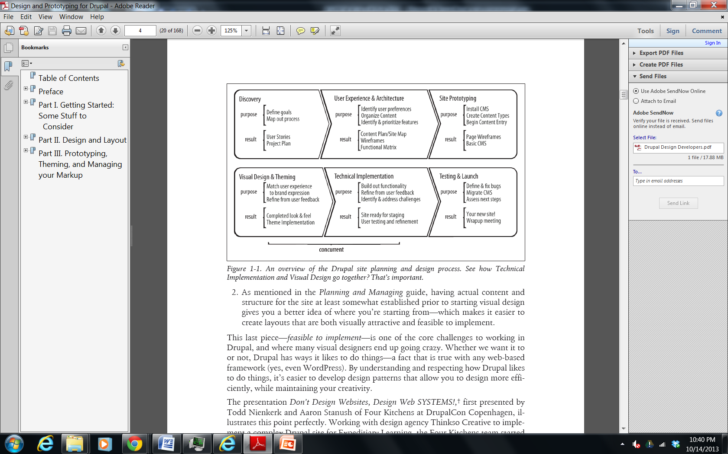
Figure 1 - From Designing and Prototyping in Drupal, D. Nordin, 2012

3.0 UA Test Environment
Phase 1 PoC Application (cloud1)
- VMware view client
- Getting a Sandbox Account (username and password) http://bitly.com/getsandboxcloudaccount
- Create Your Own WebHelpDesk (WHD) Account
- https://vacloud.us/groups/sandboxdocs/wiki/508a8/Getting_An_Innovation_Sandbox_Cloud_Account_a_login.html#step1

Phase 2 Initial UAT environment (cloud2)
Applicable IP addresses and URLs should be provided to the UAT Team and all workstations should be configured appropriately for access to the test environment.

Phase 2 Final UAT Environment (data center)
Applicable IP addresses and URLs should be provided to the UAT Team and all workstations should be configured appropriately for access to the test environment.

3.1 UA Test Preparation
Each test participant must provide the following:

Table 2 - UAT Test Preparation
Date Requested | Outstanding SME Action Item | Status
10/15/13 | Site users, roles, and keywords. | Not complete
10/24/13 | After reviewing existing protocols, provide additional protocol list and keywords. | Not complete
11/7/13 | Site’s Radlex mapping (conditional). | Not complete
11/19/13 | Review test data. | Not complete
12/5/13 | Provide site’s protocol pdfs on CD. | Not complete

3.2 UA Test Data
The table above in 3.1 shows the user test data requested for UAT.

Access to test data is a vital component in conducting a comprehensive test of the system. All UAT participants will require usage of test accounts and other pertinent test data which should be provided by end user support upon request. Participants not currently utilizing test data must receive appropriate clearance and/or permissions to perform desired actions in the UAT environment. All user roles should fully emulate production in the UAT path. Completion of an online access request may be required in order to create test accounts.

Roles and Responsibilities

Keys to a successful UAT process involve open channels of communication, detailed documentation, and above all, clearly defined roles and responsibilities. Each team member must function fluidly in a group setting as well as work independently for extended periods of time. UAT is largely a collaborative process and test results must be analyzed from different perspectives and by team members with various levels of expertise across the business to ensure success.

4.1 UAT Team
The test team is comprised of members who possess a thorough knowledge of the current systems and processing methods, i.e. SMEs. These team members will be better able to initiate test input, review the results, and be more intuitively familiar with the impact on other related business issues and staff activities. Members should be detail-oriented and be diligent in collecting proper documentation to support the test results. Team members are selected based, in part, on the ability of management to reassign the daily duties they will have to forgo while performing the testing.

All team members will be presented with an overview of the test process and what their specific role in UAT will be. SAN’s role in the UAT process is to oversee testing by assigning scripts to SMEs, providing general support, and serving as the primary UAT contact point throughout the test cycle. SAN will filter out any duplicate defects found and escalate high priority issues to the developers in a time sensitive manner.

Table 3 - Roles and Responsibilities
Name | Position | Primary Email | Alternate Email | Primary Phone | Alternate Phone
Seattle
Dr. Jonathan Medverd | Radiologist (Original Innovator) | Jonathan.Medverd@va.gov | jmed@uw.edu | (206) 764-2444 | (425) 417-2474
Glenn Zwinger | Facility CIO | Glenn.Zwinger@va.gov |  | (206)768-5485
Denice Donnelly | ISO | Denice.Donnelly@va.gov |  | (206)277-4004
Nathan Cross, MD MS | Radiologist |  | nmcross@uw.edu
Kevin Carnase, CT Tech | Technologist | kevin.carnase@va.gov
Palo Alto
Dr. Dorcas Yao | Radiologist/Informaticist | Dorcas.Yao@va.gov | dcyao@stanford.edu | (650) 493-5000 x63504
Portland, OR
Dr. Ronald Boucher | Chief of Radiology | Ronald.Boucher@va.gov |  | 503 220-8262 x56670
Jill Christensen | PACS QC Technologist | Jill.Christensen2@va.gov |  | 503 220-8262 X56517
Diana Artenian | Radiologist | Diana.Artenian@va.gov |  | 503 220-8262 x57560
Bradley Koslin | Radiologist | David.Koslin@va.gov |  | 503 220-8262 x52335
Brett Bastian | MRI Technologist | brett.bastian@va.gov |  | 503 220-8262
Brianna Ruckman | CT Technologist | Brianna.Ruckman@va.gov |  | 503 220-8262
Fresno
Dr. Arnold Friedman | Chief of Radiology Services | Arnold.Friedman@va.gov |  | (559) 225-6100 x5114
Dr. Malcolm Anderson | Radiologist | Malcolm.Anderson@va.gov |  | (559) 225-6100 x5014
Mark Gresko | DRT | Mark.Gresko@va.gov |  | (559) 225-6100 x 5033
Dr. Stan Weiss | Physician | Stan.Weiss@va.gov |  | (559) 225-6100 x 5023
Brenda Tsudama | Imaging Supervisor | Brenda.Tsudama@va.gov |  | (559) 225-6100 x5020
Ron Mills | Facility CIO (Acting) | Ron.Mills@va.gov |  | (559) 228-6901
Grady Hobbs | Health Physicist/RSO/CNMT | Grady.Hobbs@va.gov |  | (559) 225-6100 ext 5115
Jeff Skaggs | ISO | Jeff.Skaggs@va.gov |  | (559) 225-6100 Ex 6415
Tucson
Dr. Ronald Schifman | Chief of Diagnostics | Ronald.Schifman@va.gov |  | (520) 629-4629
Dr. Robert Good | Physician | Robert.Good2@va.gov |  | (520) 629-4630
Dr. Alana Stubbs | Physician | Alana.Stubbs@va.gov |  | (520) 792-1450 x4630
Dr. Ari Cohen | Physician | Ari.Cohen@va.gov |  | (520) 792-1450 x4630
Robert Shaw, ADPAC | Program Specialist | Robert.Shaw4@va.gov |  | (520) 792-1450 x6992
Michael Collins, ADPAC | Program Specialist | Michael.Collins25@va.gov |  | (520) 792-1450 x6966
John Walston | Facility CIO | John.Walston2@va.gov |  | (520) 629-4699
Derek Eckley | ISO | Derek.Eckley@va.gov |  | (520) 792-1450 Ext 6177
Edward Ohnesorgen | Chief Radiologist | Edward.Ohnesorgen@va.gov
VISN/Region Support
William Harris | VISN 21 CIO | William.Harris8@va.gov |  | (707) 562-8490
James Horner | VISN 20 CIO | James.Horner@va.gov |  | 360-750-5350
Randy Quinton | Dep. Network Director V22 | Randy.Quinton@va.gov |  | 562-826-5963
Jack Seymour | VISN 19 CIO acting 18 | Jack.Seymour@va.gov |  | (303) 504-2686
Van Gray | 18 CIO | Van.Gray@va.gov |  | 480-397-2741
Mark Cecil | R01: Dir | Mark.Cecil@va.gov |  | (208) 429-2061
Byron Youngblood | R01 CTO | Byron.Youngblood@va.gov |  | 360.816.6163
Kevin DeZorzi | R01: Div Chief Field Dev | Kevin.DeZorzi@va.gov |  | (602) 277-5551 X6738
Wilma Gonce | R01: App Svc Line Mgr | Wilma.Gonce@va.gov |  | (360) 816-6170
Jacqui Nissen | R01: IT Project Mgr | Jacqui.Nissen@va.gov |  | (307) 675-3771
Mike (James) Beverly | R01: Datacenter Contact
Contract Support
David Nostrant | Contract Officer | David.Nostrant@va.gov |  | (732) 440-9706
Sarah Basilotto | Contract Specilaist | Sarah.Basilotto@va.gov |  | (732) 440-9651
Program Office Support
Charles Anderson (SES Eqv) | Chief Consultant, Diagnostic SVCS | Charles.Anderson2@va.gov |  | (919) 382-8851

UAT Deliverables
The following sections detail milestones crucial to the completion of the UAT phase of the project. Once all dependent milestones have been completed, UAT will formally sign-off on the system’s functionality and distribute an e-mail to all project stakeholders.

5.1 UAT Activities
All core UAT activities are defined below:

- Identify UAT Team – Business Analyst lists SMEs that will take part in testing for the project. The Project Sponsor is often the source of information for the team list. A full description of team member attributes is detailed in section 4.1.
- UAT Plan – A strategy-based document defining test methodology and criteria is distributed to the team.
- UAT Plan Team Review – Session with business stakeholders to review plan and provide feedback.
- UA Test Cases – A document that details each specific test case that will be performed during the UAT process.
- UA Test Procedures – A detailed step-by-step breakdown of each individual test case.
- UA Test Case Review – Approval from business team and/or third parties on completed scripts.
- UAT Environment Validation – Validation of connectivity and expected results in the test environment for each end user participating in testing.
- Test Case Execution – Completion of all test scripts by test team.
- Defect Tracking – Defects will be entered and tracked via spreadsheet by the Business Analyst and/or Project Manager. Each entry will include detailed information about each defect.
- UAT Touch Point – Regularly scheduled meeting to evaluate UAT progress and outstanding defects.
- UAT Sign-Off – Formal sign-off indicating the system satisfies the needs of the business as specified in the functional requirements and provides confidence in its use.

5.2 UAT Schedule
[List key deliverable dates and milestones in the table below]

Table 4 - UAT Schedule
Item | Activity | Estimated Completion Date | Initials
1 | Identify UAT Team
2 | UAT Plan
3 | UAT Plan Team Review
4 | UA Test Case Walk Through
5 | Test Data Acquisition
6 | UA Test Scripts
7 | UA Test Script Approval
8 | Desktop Validation
9 | UAT Environment Validation
10 | Test Script Execution
11 | UAT Sign-Off

6.0 UA Test Cases
[Describe test case approach and provide link to full document]

Test cases provide a high-level description of the functionality to be tested. All regression and new functionality test cases are contained in the Excel spreadsheet “UA Test Cases” available at: [insert hyperlink to UAT folder in Project Directory here]. The team plans to leverage relevant QA test cases for project specific functionality. Each test case based on new functionality will reference a specific functional requirement.

6.1 UA Test Cases
Test cases contain a detailed step by step breakdown of each test case to be performed by the UA tester. Each script contains: test case number, product, test description, requirement number, requestor, tester, action to be performed, test data to be utilized, expected results, error descriptions (if applicable), pass/fail results, date tested, and any additional comments from the UA tester.

The UA test scripts are contained within the UAT test case spreadsheet and can be accessed via hyperlink from each individual test case.

UAT Defects
[Describe the defect capture and prioritization methods]

Defects will be entered and tracked via the VHA Innovation Program web help desk http://help.vacloud.us:8080/helpdesk/WebObjects/Helpdesk.woa/wo/79.9.1.1.1.0 by VA SMEs during the UAT process. Each entry will include detailed information about each defect.

7.1 UAT Defect Tracking
Team members will be provided with instruction on how to effectively execute test scripts, as well identify, capture, and report defects. Utilization of Microsoft Office applications and screen capture programs (e.g. SnagIt) will be required to document defects for escalation. Team members will be expected to present findings on regularly scheduled touch point meetings in the event that end user support and/or Development require additional detail.

7.2 UAT Defect Prioritization
The Business Analyst will function as a liaison between the business and development on matters of prioritizing and classifying defects. Defects found in UAT can be assigned one of four (4) levels of severity:

- Regulatory – This request is regulatory and mandatory
- Critical – Testing defects that due to the complexity of the function or the scheduled dates are putting the implementation date at risk. No workaround exists.
- High – Testing defects occurring in a less complex function of the application with sufficient time to resolve before the implementation date – but must be implemented as scheduled. A workaround has been identified and is listed in the defect.
- Low – Testing defect occurring in a function that are simple to fix or could be excluded if not resolved by the scheduled implementation date.

7.3 UAT Defect Lifecycle
Defects must be clearly captured and escalated to ensure prompt resolution by development. Each defect submitted by UAT will be assigned a priority, worked by development, resolved, and re-tested by UAT prior to closure. The following is a snapshot of the standard defect lifecycle:

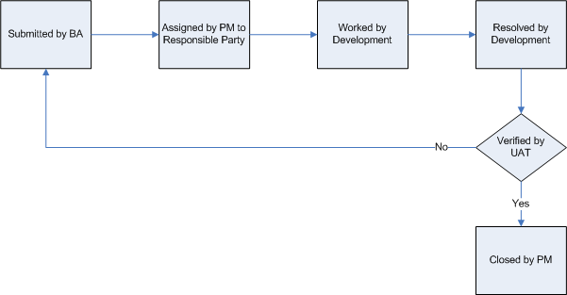
Figure 2 - UAT Defect Lifecycle

Assumptions
[Identify any assumptions prior to UAT]

The following are key assumptions made by UAT prior to the commencement of the acceptance test phase:

- QA testing has been completed without any outstanding critical defects.
- The UAT environment will be available for testing.
- Configuration information and test data has been provided and applied as designed.
- All desktops identified for UAT will have the necessary software applications installed.
- Subject Matter Experts (SME) are available to participate in testing.

